**DAILY ONLINE ACTIVITIES SUMMARY**

|  |  |  |  |  |  |  |  |  |
| --- | --- | --- | --- | --- | --- | --- | --- | --- |
| **Date:** | **05/06/2020** | | | | | **Name:** | **Rahul J** | |
| **Sem & Sec** | **8th sem B sec** | | | | | **USN:** | **4AL16CS130** | |
| **Online Test Summary** | | | | | | | | |
| **Subject** | | **BDA** | | | | | | |
| **Max. Marks** | | **30** | | **Score** | | | **17** | |
| **Certification Course Summary** | | | | | | | | |
| **Course** | **Cloud foundations** | | | | | | | |
| **Certificate Provider** | | | **Great learning** | | **Duration** | | | **4.5 Hours** |
| **Coding Challenges** | | | | | | | | |
| **Problem Statement:**  **C program on strings** | | | | | | | | |
| **Status: Solved** | | | | | | | | |
| **Uploaded the report in Github** | | | | | **Uploaded** | | | |
| **If yes Repository name** | | | | | **Rahul_j** | | | |
| **Uploaded the report in slack** | | | | | **Yes** | | | |

Online Test Details: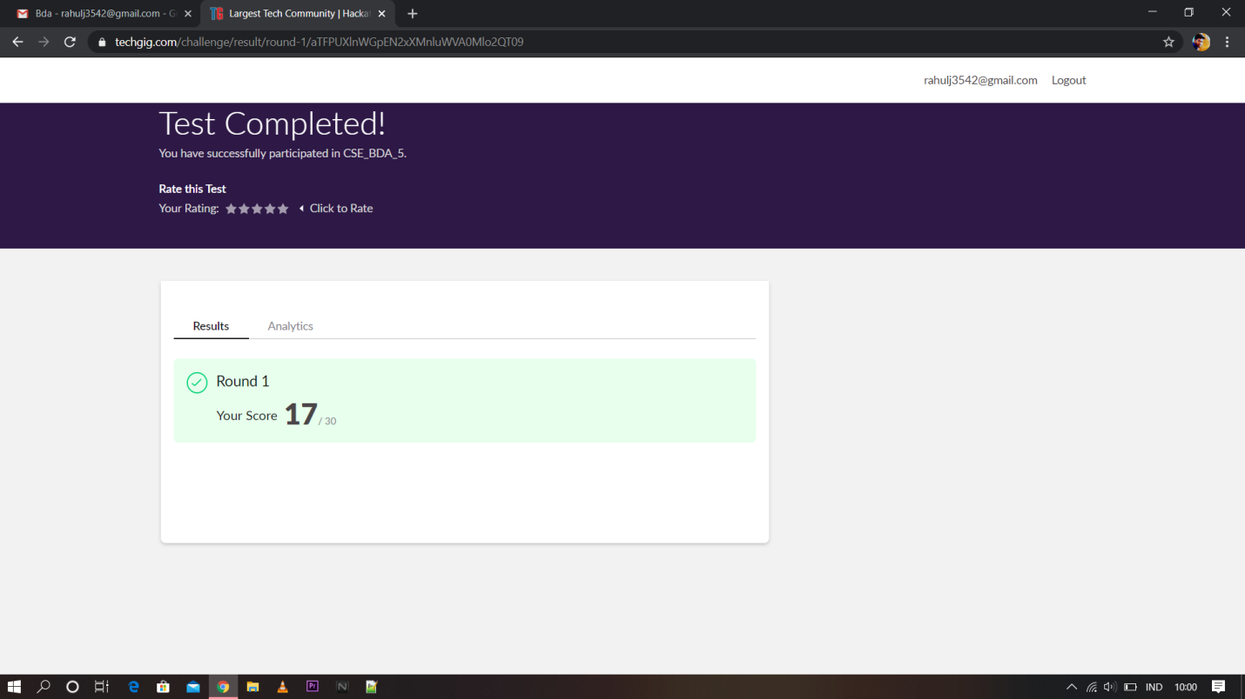

Certification Course Details:

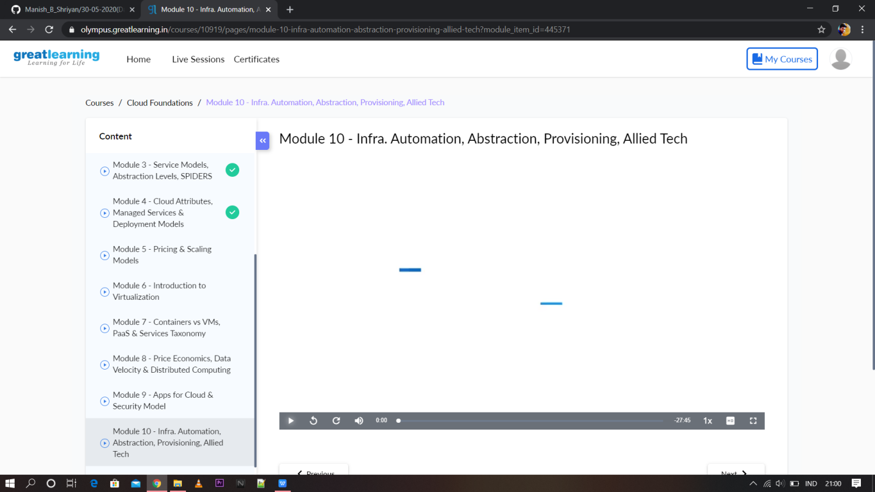

Coding Challenges Details:

|  |
| --- |
|  |
|  |  |
|  |  |
|  |  |
|  |  |
|  |  |
|  |  |
|  |  |
|  |  |
|  |  |
|  |  |

#include <stdio.h>

#include <string.h>

int main()

{

char str[100];

int i;

int freq[256] = {0};

printf("Enter a string\n");

gets(str);

for(i = 0; str[i] != '\0'; i++)

{

freq[str[i]]++;

}

for(i = 0; i < 256; i++)

{

if(freq[i] != 0)

{

printf("%c %d\n", i, freq[i]);

}

}

return 0;

}